Entry No.
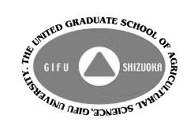

Application March 2018 UGSAS-GU International symposium on Innovative Crop Protection for Sustainable Agriculture

Application Deadline: November 20, 2017 Send Application to ugsasnet@gifu-u.ac.jp
Note: We will screen all applications and bring the result to you within November, 2017 via e-mail.
- Applicants Name:

Name to be Printed on Official Certificates (with Degrees)

UGSAS Alumni(ae) ? ( YES / NO ) -- IF YES, Graduation Month & Year:

Field of Expertise:

Highest Academic Degree You Hold:

Gender & Birthday:

Nationality:

Current Workplace (including Department and Position):

Current Residence Address:

Phone Number:

E-mail Address:
2．Presentation Title:

3. Presentation Abstract (No more than 200 WORDS):

