Entry No.
Application
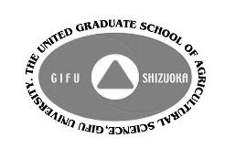
2017 UGSAS-GU International Symposium
on Soil Management for Sustainable Agriculture

Application Deadline: May 31, 2017 Send Application to ugsas_dn@gifu-u.ac.jp
Note: We will conduct screening of all the applications and bring the result to your notice by the end of June, 2017 via e-mail..
- Applicants Name:

Gender:

Nationality:

Academic Degree:

UGSAS Graduation Date & Year:

Current Workplace and Title/Position:

Field of Expertise:

Current Residence Address:

Phone Number:

E-mail Address:
2．Presentation Title:

3．Abstract of Presentation (No more than 200 words):

－The United Graduate School of Agricultural Science, Gifu University－

